The detailed design section provides comprehensive diagrams that illustrate the system's functionality, interactions, and data structure. These diagrams include use case, sequence, collaboration, activity, and database design diagrams.
5.1 Use Case Diagram
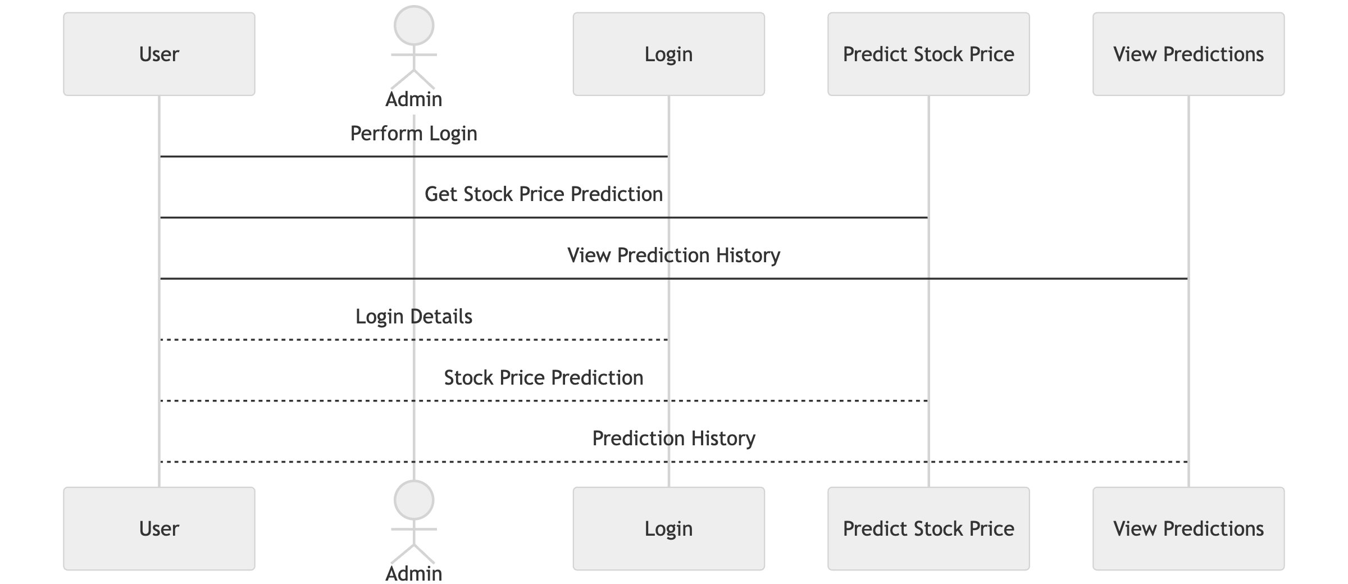
A use case diagram represents the functional requirements of the system from the user's perspective, showing the interactions between users (actors) and the system.

Fig 1. Use Case Diagram

Actors:
- User: Any individual who interacts with the system to predict stock prices or view historical predictions.
- Admin: User with additional privileges to manage the system, including user management and data maintenance.
Use Cases:
- Login: Authenticate users.
- Predict Stock Price: Input historical data to receive a stock price prediction.
- View Predictions: View past predictions and their accuracy.

5.2 Sequence Diagram
A sequence diagram shows the interactions between different entities in the system over time for a specific scenario.

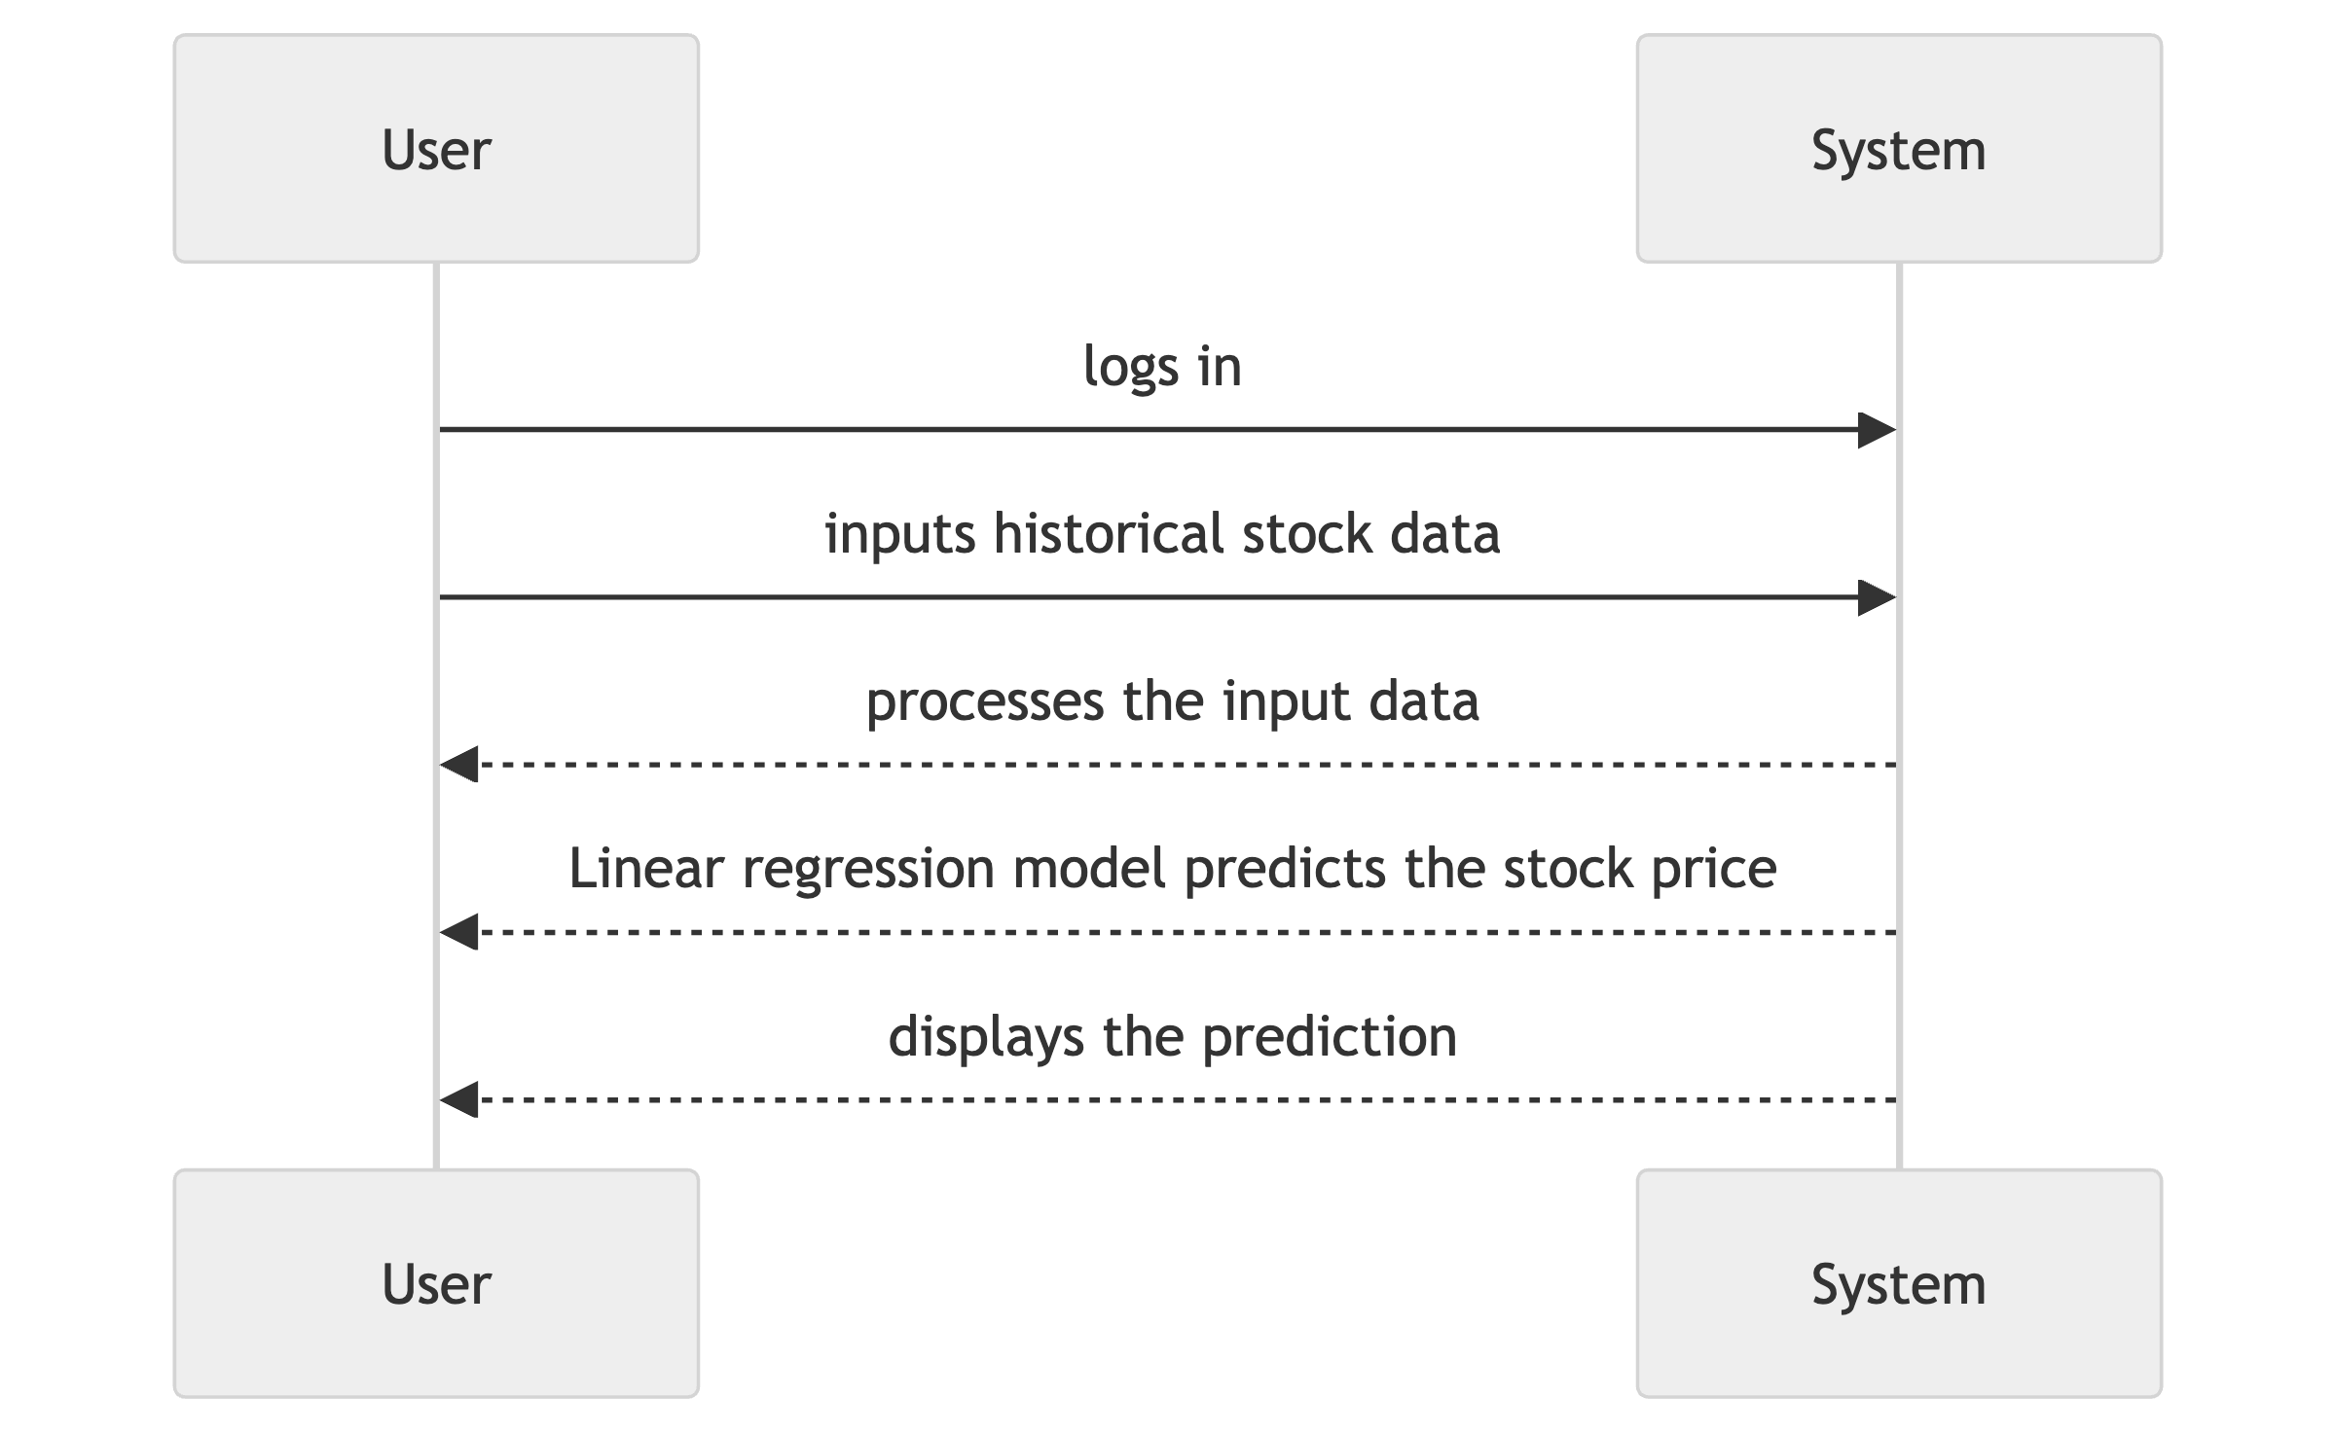

Fig 2. Sequence Diagram for Stock Price Prediction

Scenario: Predicting Stock Price
- User logs in.
- User inputs historical stock data.
- The system processes the input data.
- Linear regression model predicts the stock price.
- The system displays the prediction to the user.

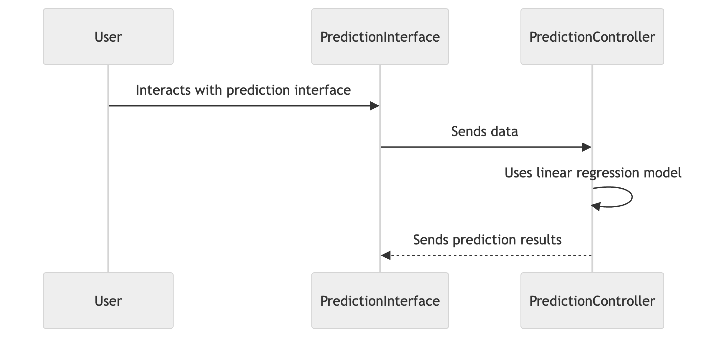
5.3 Collaboration Diagram
A collaboration diagram illustrates the interactions between objects and the sequence in which those interactions occur.

Fig 3. Collaboration Diagram for Stock Price Prediction

Interactions:
- User interacts with the prediction interface.
- Prediction interface sends data to the prediction controller.
- Prediction controller uses the linear regression model to predict the price.
- Prediction results are sent back to the user.

5.4 Activity Diagram
An activity diagram depicts the workflow of activities within the system, showing the flow of control from one activity to another.
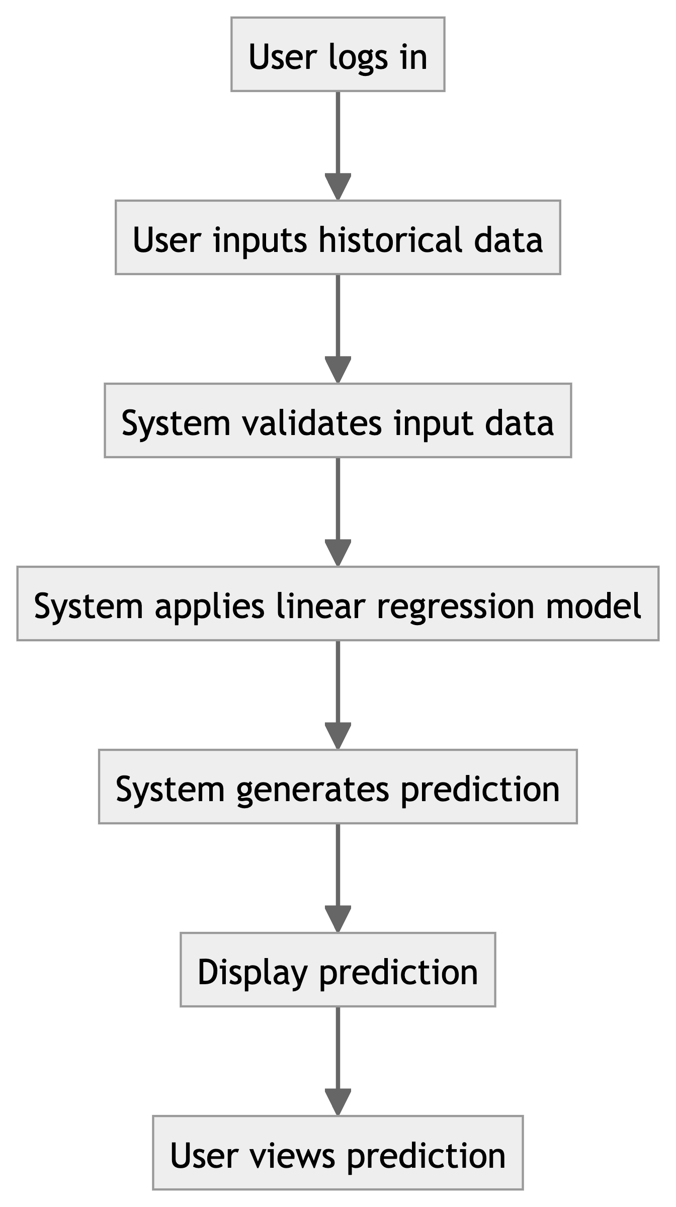

Fig 4. Activity Diagram for Predicting Stock Price

Workflow:
- User logs in.
- User inputs historical data.
- System validates input data.
- System applies linear regression model.
- System generates and displays the prediction.
- User views the prediction.

5.5 Database Design (ER And/Or Conceptual Schema)
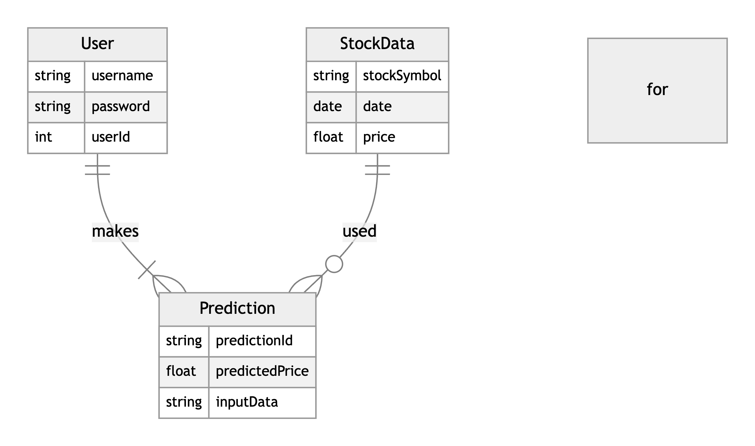
The Entity-Relationship (ER) diagram models the database structure and the relationships between different entities in the system.

Fig 5. ER Diagram for Stock Price Prediction System

Entities:
- User: Stores user information and authentication details.
- StockData: Stores historical stock data used for predictions.
- Prediction: Stores the predictions generated by the system, including input data and predicted prices.
Relationships:
- User "makes" Prediction
- StockData "used for" Prediction
These design diagrams collectively provide a comprehensive view of the system's functionality, interactions, and data structure, guiding the implementation and development process of the Microsoft Stock Price Prediction system.

